**LPP WITH SIMPLEX METHOD**

*Submitted in Partial Fulfillment of the Second Continuous Assessment*

**Bachelor of Technology**

In

Computer Science and Engineering (AI&ML)

*4th semester*

**NAME: ADITIYA KUMAR**

**UNIVERSITY ROLL NO:**

**UNIVERSITY REGISTRATION NO:**

**PAPER NAME: OPTIMIZATION TECHNIQUE**

**PAPER CODE: PCCAIML-402**



*Under the guidance of*

**Paper Faculty**

**Name:**

**Designation: Teacher**

**Department of CSE (AI&ML)**

**Future Institute of Technology**

**March 2023.**

|  |  |  |
| --- | --- | --- |
| **SL NO.** | **TOPIC** | **PAGE NO.** |
| 1. | ABSTRACT | 3 |
| 2. | INTRODUCTION | 3 |
| 3. | PROBLELM DEFINITION | 3 |
| 4. | OBJECTIVE | 3 |
| 5. | MINIMIZATION AND MAXIMATION IN LPP | 4-9 |
| 6. | DISCUSSION | 9-10 |
| 7. | CONCLUSION AND REFERENCE | 10 |

* **INDEX**
* **ABSTRACT:**

In the following report, we are going to talk about solving a linear programming problem using the simplex method. The Simplex method is an algebraic procedure in which a series of repetitive operations are used to reach at the optimal solution. The Simplex method is the most popular and successful method for solving linear programs. The objective function of a linear programming problem (LPP) involves the maximization and minimization problem with the set of linear equalities and inequalities constraints. There are different methods to solve LPP, such as simplex, dual-simplex, Big-M, and two-phase methods. In this paper, an approach is presented to solve LPP with a new seven steps process by choosing the “key element rule” which is still widely used and remains important in practice. We propose a new technique i.e. a seven-step process in LPP for the simplex, dual-simplex, Big-M, and two-phase methods to get the solution with complexity reduction.

* **INTRODUCTION:**

The Simplex method is an approach to solving linear programming models by hand using slack variables, tableaus, and pivot variables as a means to finding the optimal solution of an optimization problem. A linear program is a method of achieving the best outcome given a maximum or minimum equation with linear constraints. Most linear programs can be solved using an online solver such as Mat Lab, but the Simplex method is a technique for solving linear programs by hand. To solve a linear programming model using the Simplex method the following steps are necessary:

* Standard form
* Introducing slack variables
* Creating the tableau
* Pivot variables
* Creating a new tableau
* Checking for optimality
* Identify optimal values
* **PROBLEM DEFINITION:**

Solve the following LPP by using simplex method; Max Z = 6x1 + 4x2

Subject to x1 + 2x2 ≤ 720 , 2x1 + x2 ≤780 , x1 ≤320

* **OBJECTIVE:**

**Maximization LPP:**

1. **Step 1: Convert the Following LPP into Standard Form**

Max Z = 6x1 + 4x2 + 0S1 + 0S2 + 0S3

Subject to x1 + 2x2 + S1 = 720 ; 2x1 + x2 + S2 = 780; x1 + S3 = 320

1. **Step 2: Initial Basic Feasible Solution**

x1 = 0 and x2 = 0 in the above equation then we have S1 = 720, S2 = 780 and S3 = 320

Table 1: Initial Solution

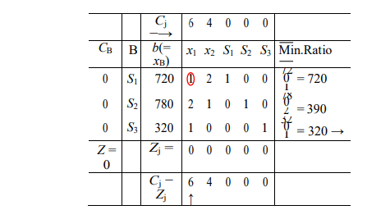

1. **Step 3: Perform the Optimality Test** :

Since all Cj − Zj ≥ 0(j = 1, 2), the current solution is not optimal. Variable x1 is chosen to enter into the basis as C1 −Z1 = 6 is the largest positive number in the x1 column, where all elements are positive. This means that for every unit of variable x1, the objective function will increase in value by 6. The x1 column is the key column.

1. **Step 4: Determine the Variable to Leave the Basis**:

The variable to leave the basis is determined by dividing the value in the xB- (constant) column by their corresponding elements in the key column as shown in Table 1. Since the exchange ratio, 320 is minimum in row 3, the basic variable S3 is chosen to leave the solution basis. Iteration 1: Since the key element enclosed in the circle in Table 1 is 1, this row remains unchanged. The new values of the elements in the remaining rows for the new Table is obtained by performing the following elementary row operations on all rows so that all elements accept the key element 1 in the key column are zero. R3(old) R3(new) → 1(key element) = (320, 1, 0, 0, 0, 1) R2(new) →R2(old) −2R3(new) R2(new) →(780,2,1,0,1,0) −2(320,1,0,0,0,1) = (140,0,1,0,1,−2) R1(new) →R1(old) −1R3(new) R1(new) →(720,1,2,1,0,0) −1(320,1,0,0,0,1) = (400,0,2,1,0,−1) Then, the new improved solution is given in 2 below; An improved basic feasible solution can be read from Table 2 as: x1 = 320, S2 = 140, S3 = 400 and x2 = 0. The improved value of objective function is Z=1920. Once again, calculate values of Cj − Zj in the same manner as we have done to get the improved solution in Table 2 to see whether the solution is optimal or not. Since C2 − Z2 > 0, the current solution is not optimal.

Table 4.2: Improved Solution

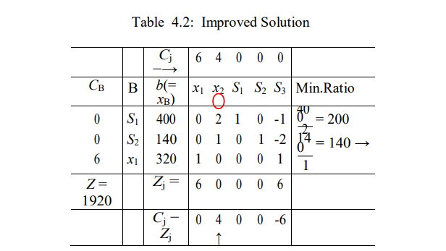

Iteration 2: Repeats steps 3 to 4. Table 3 is obtained by performing following row operations to enter x2 into the basis and to drive out S2 from the basis. R2(old) R2(new) → 1(key element) = (140, 0, 1, 0, 1, −2)

R1(new) →R1(old) −2R2(new) R1(new) →(400,0,2,1,0,−1) −2(140,0,1,0,1,−2) =(120,0,0,1,−2,3) R3(new) →R3(old)−0R2(new) R3(new) →(320,1,0,0,0,1) −0(140,0,1,0,1,−2) = (320,1,0,0,0,1) Then, the improved solution for iteration 2 is given in Table 3 below;

Table 3: Improved Solution

Iteration 3: Repeats steps 3 to 4. Table 4 is obtained by performing following row operations to enter S3 into the basis and to drive out S1 from the basis. R1(old) R1(new) → 3(key element) = (40, 0, 0, 1/3, −2/3, 1)

R2(new) →R2(old)+ 2R1(new) R2(new)→(140,0,1,0,1,−2)+2(40,0,0,1/3,−2/3,1)=(220,0,1,2/3,−1/3,0) R3(new) →R3(old) −1R1(new) R3(new)→(320,1,0,0,0,1)−1(40,0,0,1/3,−2/3,1) =(280,1,0,−1/3,2/3,0) Then, the improved solution for iteration 2 is given in Table 4 below;

Table 4: Optimal Solution

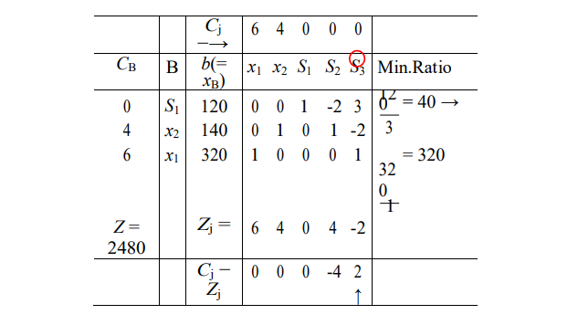

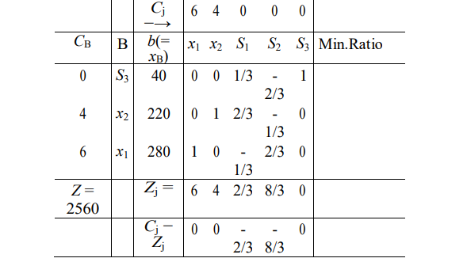

Since all Cj −Zj ≤ 0 corresponding to non - basic variables columns, the current solution cannot be improved further. This means that the current basic feasible solution is also the optimal solution. Thus, x1 = 280, x2 = 220 and the value of objective function is Z=2560.

**Minimization LPP:**

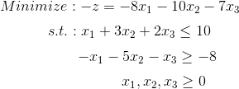

**Solution:**

**Step 1: Standard Form**

Standard form is the baseline format for all linear programs before solving for the optimal solution and has three requirements: (1) must be a maximization problem, (2) all linear constraints must be in a less-than-or-equal-to inequality, (3) all variables are non-negative. These requirements can always be satisfied by transforming any given linear program using basic algebra and substitution. A standard form is necessary because it creates an ideal starting point for solving the Simplex method as efficiently as possible as well as other methods of solving optimization problems.

To transform a minimization linear program model into a maximization linear program model, simply multiply both the left and the right sides of the objective function by -1.

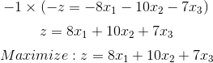 Transforming linear constraints from a greater-than-or-equal-to inequality to a less-than-or-equal-to inequality can be done similarly as what was done to the objective function. By multiplying by -1 on both sides, the inequality can be changed to less-than-or-equal-to.

https://miro.medium.com/v2/resize:fit:225/0*EsVeMHI0Ht8JFYZt.png Once the model is in standard form, the slack variables can be added as shown in Step 2 of the Simplex method.

**Step 2: Determine Slack Variables**

Slack variables are additional variables that are introduced into the linear constraints of a linear program to transform them from inequality constraints to equality constraints. If the model is in standard form, the slack variables will always have a +1 coefficient. Slack variables are needed in the constraints to transform them into solvable equalities with one definite answer.

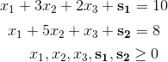

After the slack variables are introduced, the tableau can be set up to check for optimality as described in Step 3.

**Step 3: Setting up the Tableau**

A Simplex tableau is used to perform row operations on the linear programming model as well as to check a solution for optimality. The tableau consists of the coefficient corresponding to the linear constraint variables and the coefficients of the objective function. In the tableau below, the bolded top row of the tableau states what each column represents. The following two rows represent the linear constraint variable coefficients from the linear programming model, and the last row represents the objective function variable coefficients.

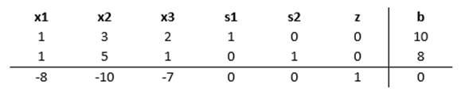

Once the tableau has been completed, the model can be checked for an optimal solution as shown in Step 4.

**Step 4: Check Optimality**

The optimal solution of a maximization linear programming model is the values assigned to the variables in the objective function to give the largest zeta value. The optimal solution would exist on the corner points of the graph of the entire model. To check optimality using the tableau, all values in the last row must contain values greater than or equal to zero. If a value is less than zero, it means that the variable has not reached its optimal value. As seen in the previous tableau, three negative values exist in the bottom row indicating that this solution is not optimal. If a tableau is not optimal, the next step is to identify the pivot variable to base a new tableau on, as described in Step 5.

**Step 5: Identify Pivot Variable**

The pivot variable is used in row operations to identify which variable will become the unit value and is a key factor in the conversion of the unit value. The pivot variable can be identified by looking at the bottom row of the tableau and the indicator. Assuming that the solution is not optimal, pick the smallest negative value in the bottom row. One of the values lying in the column of this value will be the pivot variable. To find the indicator, divide the beta values of the linear constraints by their corresponding values from the column containing the possible pivot variable. The intersection of the row with the smallest non-negative indicator and the smallest negative value in the bottom row will become the pivot variable.

In the example shown below, -10 is the smallest negative in the last row. This will designate the *x2* column to contain the pivot variable. Solving for the indicator gives us a value of 10/3 for the first constraint and a value of 8/5 for the second constraint. Due to being the smallest non-negative indicator, the pivot value will be in the second row and have a value of 5.

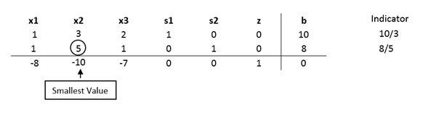

Now that the new pivot variable has been identified, the new tableau can be created in Step 6 to optimize the variable and find the new possible optimal solution.

**Step 6: Create the New Tableau**

The new tableau will be used to identify a new possible optimal solution. Now that the pivot variable has been identified in Step 5, row operations can be performed to optimize the pivot variable while keeping the rest of the tableau equivalent.

I. To optimize the pivot variable, it will need to be transformed into a unit value (value of 1). To transform the value, multiply the row containing the pivot variable by the reciprocal of the pivot value. In the example below, the pivot variable is originally 5, so multiply the entire row by 1/5

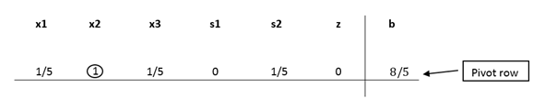

II. After the unit value has been determined, the other values in the column containing the unit value will become zero. This is because the x2 in the second constraint is being optimized, which requires x2 in the other equations to be zero.

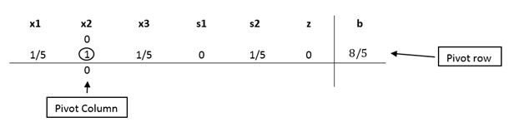

III. In order to keep the tableau equivalent, the other variables not contained in the pivot column or pivot row must be calculated by using the new pivot values. For each new value, multiply the negative of the value in the old pivot column by the value in the new pivot row that corresponds to the value being calculated. Then add this to the old value from the old tableau to produce the new value for the new tableau. This step can be condensed into the equation on the next page:

New tableau value = (Negative value in old tableau pivot column) x (value in new tableau pivot row) + (Old tableau value)

***Old Tableau:***

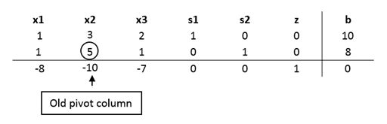

***New Tableau:***

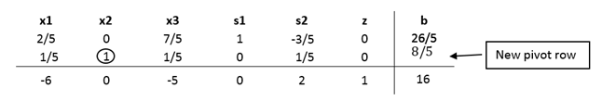

* **DISCUSSION:**

**APPLICATION:**

1. Simplex Method Overcomes the major disadvantage of graphical method which is its inability to solve problems involving more than two products.

2. It offers tremendous help to managers in the application or utilization of CVP analysis in areas like (a) product planning decision (1,) profit planning decision and (c) Pricing decision.

3. Simplex method is very appropriate and superior to some of the tools or techniques used in capital budgeting, and price transfer. It helps to guide the management on the maximum or minimum investment in a particular portfolio.

**ADVANTAGES**

**The main advantages of simplex method is that these type of computerized methods are more easy to handle and these are much more powerful than the old graphical method and these also provides the optimal kind of solution to the results.**

For complex problems involving many variables, the Simplex method is much faster than other algorithms at solving linear systems. The Simplex method's efficiency is important for computer programming, as the need for processing power is significantly lower when using it.

**LIMITATION:**

1. Size of the linear programming problem that can be solved on today’s powerful computers in a reasonable amount of time (say at most a couple of days). Linear programs with 10 - 50 million constraints and a few hundred million variables have been solved.
2. Ability to exploit parallelism. The current simplex method implementations do not parallelize particularly well, as the work in each iteration is spread out over multiple sequential tasks. The barrier algorithm and other interior point methods parallelize much better. Some progress has been made with the simplex method, but much work remains to be done, especially for scaling up to a large number of threads.
3. Complexity. The worst case behavior at this point is still exponential. Nobody has yet found a strongly polynomial pivoting rule for the simplex method.

* **CONLUSION:**

The Simplex method is an approach for determining the optimal value of a linear program by hand. The method produces an optimal solution to satisfy the given constraints and produce a maximum zeta value. To use the Simplex method, a given linear programming model needs to be in standard form, where slack variables can then be introduced. Using the tableau and pivot variables, an optimal solution can be reached.

* **REFERENCE:**

<https://medium.com/>

<https://www.shivajicollege.ac>

<https://papers.ssrn.com/>